**PROJECT REPORT FOR THE TABLEAU HR SCORECARD : MEASURING SUCCESS IN TALENT MANAGEMENT**

**1.INTRODUCTION**

**1,1 overview**

Talent management stands as a cornerstone in the modern business landscape, with organizations recognizing that their people are the most valuable assets. A robust talent management strategy not only attracts and retains top-tier employees but also fuels innovation, growth, and sustained success. However, devising and executing a talent management strategy is just the beginning; measuring its effectiveness is the true litmus test of its impact.

**1.2 Purpose**

Talent management is how employers recruit and develop a workforce that is as productive as possible and likely to stay with their organization long term. When implemented strategically, this process can help improve the overall performance of the business and ensure that it remains competitive.

**2.PROBLEM DEFINITION AND DESIGN THINKING**

**2.1 EMPATHY MAP**

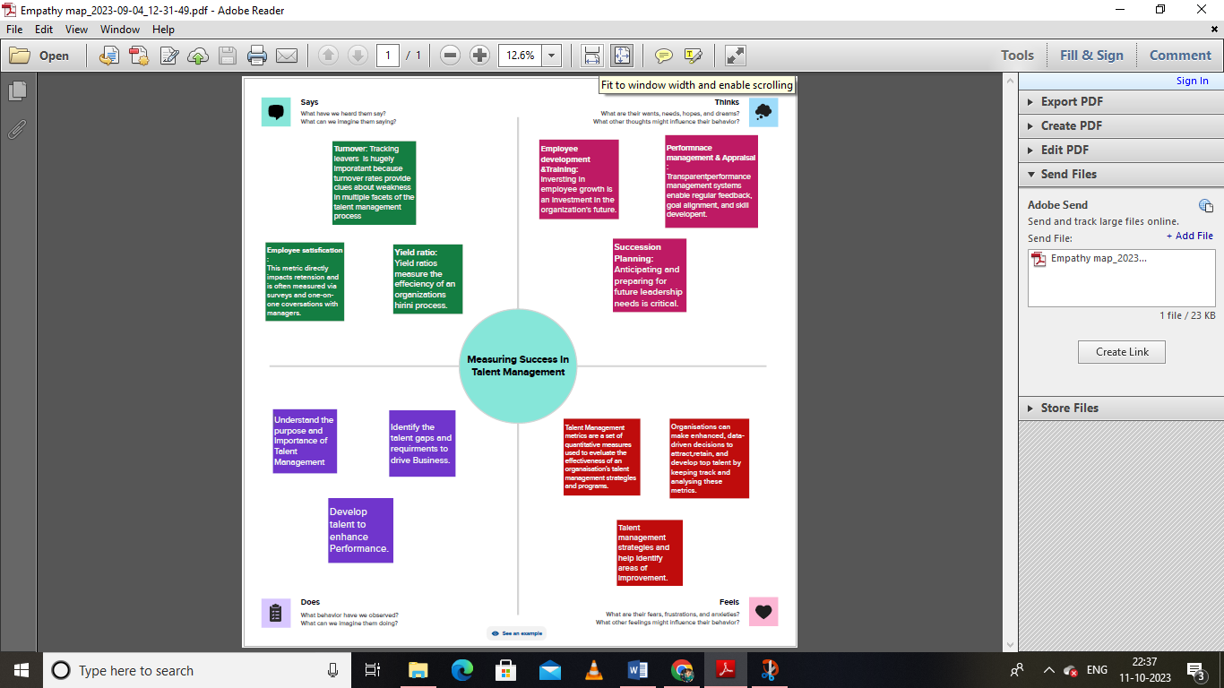

**2.2 IDEATION AND BRAINSTROMING MAP**

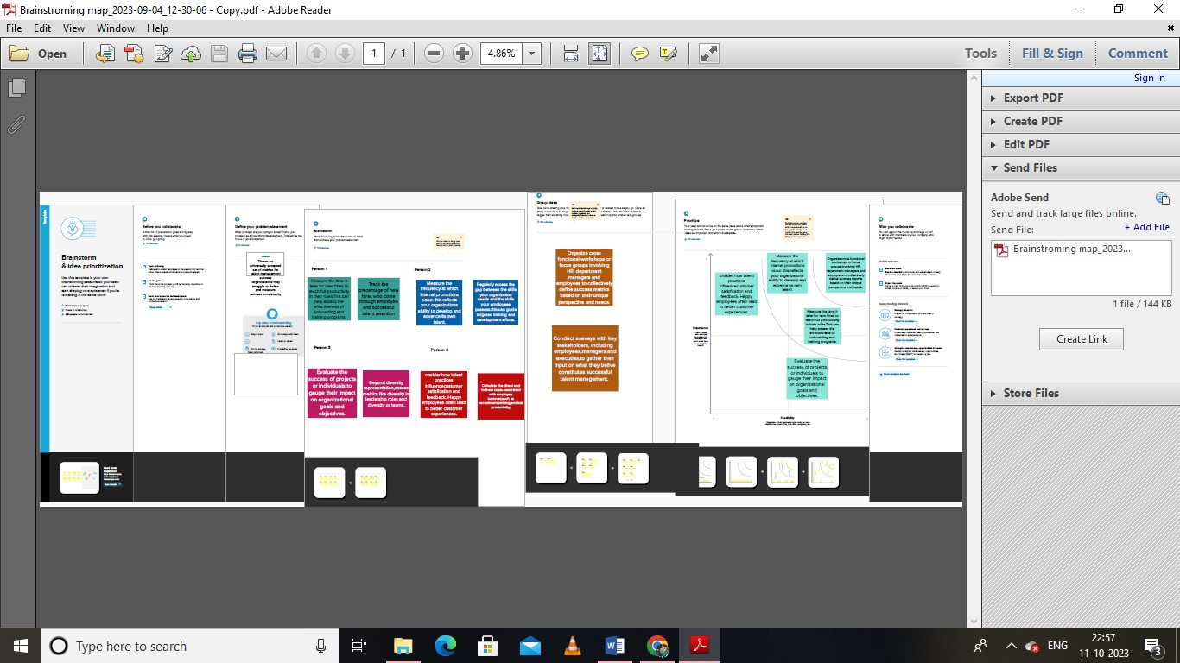

**3.RESULT :**

**Talent Managemant Sub Branches:**

**1.Internal Promotion Rate : Turning inward to find talent can decrease recruitment costs, reduce turnover, and improve retention.**

**2.Employee Turnover Rate :**  **A high turnover rate means many of your employees are leaving the organisation.**

**3.Retention Rate : Employee retention is your ability to keep the employees you want in your business.**

**4.Employee Distribution :** **Distribution is a fundamental metric to track when representing diversity, equity, and inclusion goals and identifying unconscious bias.**

**5.Hiring Cost : Helpfully, there is a standardised definition of cost to hire, which lists all the internal and external costs that need to be included in the metric.**

**DASHBOARD**

**1.**

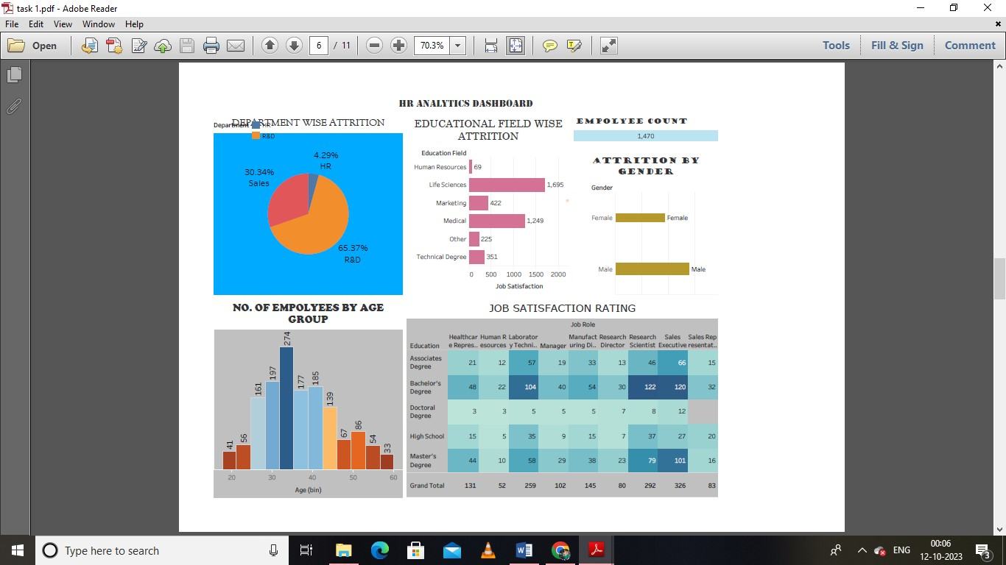

**STORY**

**1.**

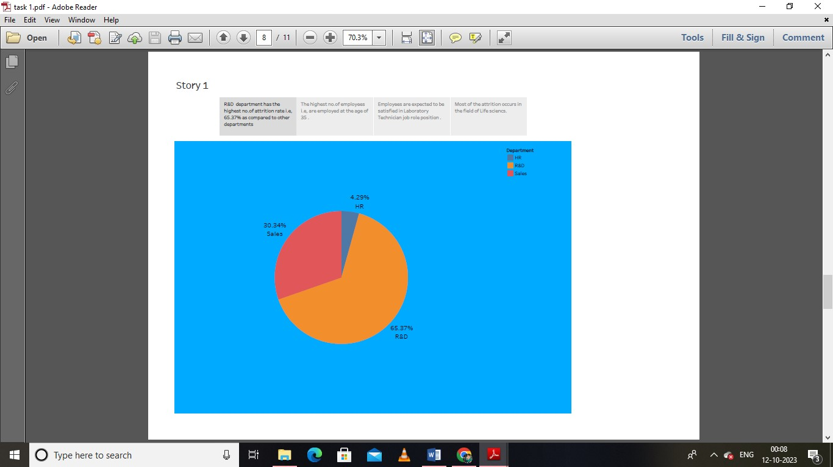

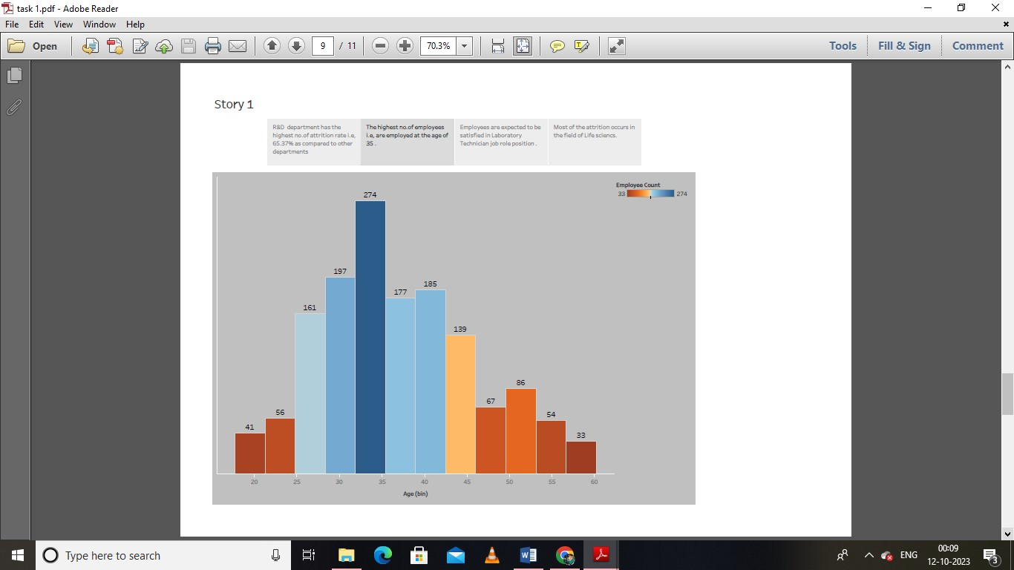

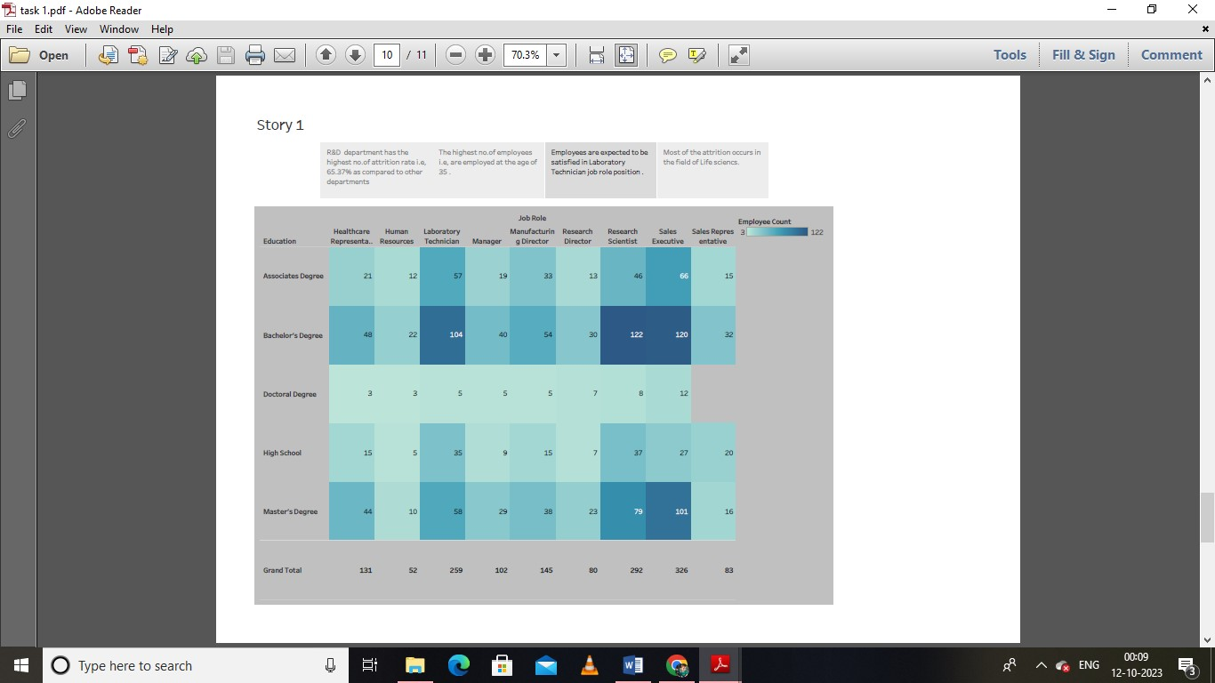

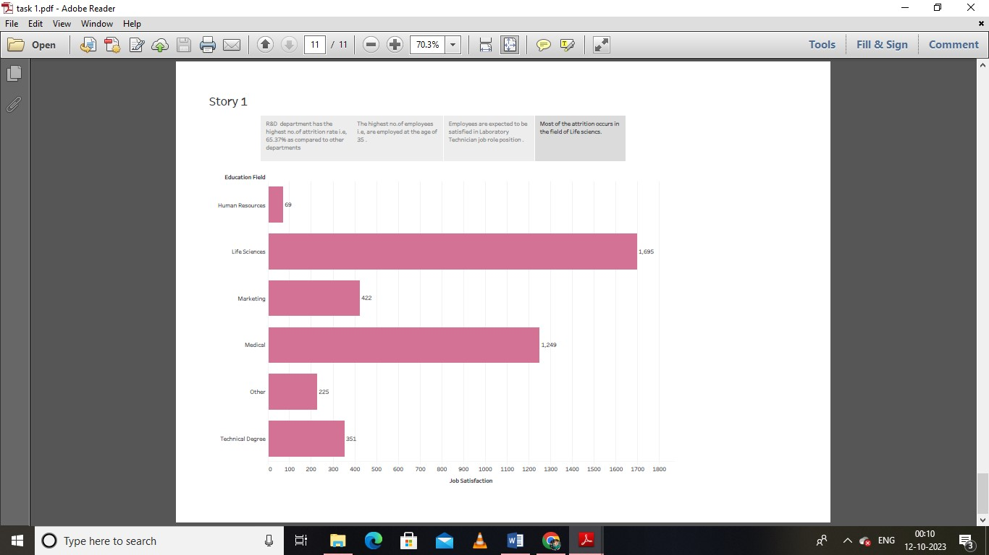

**4.ADVANTAGES AND DISADVANTAGES**

**4.1 ADVANTAGES OF TALENT MANAGEMENT**

**1.** Talent management team helps the organization in identifying and improving the skillset and knowledge of the employees through various approaches.

2. One of the major issues seen with the workforce is the constant attrition and the turnover of the staff these days.

3. With such a dearth of skilled manpower and hard timing finding the right talent for the job, the right companies who want to progress need to identify the right talent and the skillset in the market

4. The talent management team helps in fostering a culture of continuous learning and development along with various engaging and interaction-building approaches within the organization.

5. With talent management setup or team working in an organization, the overall recruitment cost for the company as a whole decreases by a larger number.

**4.2 DISADVANTAGES ROR TALENT MANAGEMENT**

1. The talent management concept as a whole is a complex topic and not many organizations and companies have the right team, time, resources, and capacity to run it to its full potential.

2. The concept of a human resource department or team has been around for a long.

3. The duty calls and responsibilities of talent management vary between short-term and long-term goals.

4. Modern-day organizations run on stats and data.

5.  It requires a specific individual or a team of individuals with a core focus on managing the talent.

6.  Overemphasis on one aspect of it can lead to the detrimental effect on the other side.

**5. APPLICATIONS :**

**1.** Talent management metrics are essential because they provide organizations with a way to evaluate the effectiveness of their talent management strategies and programs.

2. By tracking and analyzing these metrics, organizations can make data-driven decisions to attract, retain, and develop top talent

3. According to a survey by Deloitte, 84% of organizations believe that talent management is critical to their success, yet only 22% feel that they are effective at it.

4. In a survey by McKinsey, companies with diverse executive teams were 33% more likely to outperform their peers on profitability.

5. This highlights the importance of measuring and improving diversity and inclusion in the organization.

**6.CONCLUSION :**

In conclusion, talent development metrics is a vital tool for HR professionals in measuring the effectiveness of their talent management strategies.

By tracking metrics such as time-to-fill, cost-per-hire, employee turnover rate, employee engagement, retention rate, diversity and inclusion metrics, succession planninng metrics and performance and productivity metrics, HR professionals can make data-drivn decisions that can help improve the overall performance of their organisation .

7. FUTURE SCOPE FOR TALENT MANAGEMENT.:

1. We propose four shifts for talent management to move into the next era of work that will be characterized by AI, labor shortages, work without boundaries, and workforce ecosystems.

2. In its current state, talent management will not rise to future challenges. Only 13% of HR leaders rate their talent management practices as ‘excellent,’ while 70% of HR leaders rate their organization’s ability to address their talent needs as ‘mediocre.

3. There are three crucial tipping points that will shape the future of talent management.

4.’ Yet, to date, [talent management](https://www.aihr.com/blog/what-is-talent-management/) has done little to ensure that organizations can access, nurture, and retain the talent they need. We see this in low engagement rates, high turnover and attrition, and over [50% of employees](https://www.forbes.com/advisor/business/hr-statistics-trends/) browsing for opportunities outside of their organization.